# A Real-Time Physiotherapy Pose Monitoring and Feedback System Using Machine Learning

# Prof. Jaitee Bankar1, Jay Patil2, Atharv Chormale3, Chaitanya Pathak*4*.

1Assistant Professor, 2,3,4Student.

IT Department, Savitribai Phule Pune University, Sinhgad College of Engineering, Warje.

E-mails: [jaiteebankar.rmdssoe@sinhgad.edu](mailto:jaiteebankar.rmdssoe@sinhgad.edu) (Prof. Jaitee Bankar), [jaydinesh1111@gmail.com](mailto:jaydinesh1111@gmail.com) (Jay Patil), [atharvchormale27@gmail.com](mailto:atharvchormale27@gmail.com) (Atharv Chormale), [Chaitanyapathak218@gmail.com](mailto:Chaitanyapathak218@gmail.com) (Chaitanya Pathak).

**ABSTRACT**

*Domestic physical therapy exercises often lack professional supervision, which can slow recovery or lead to further injuries. This project uses computer vision and machine learning to provide real-time pose recognition and feedback systems. This is specialized for general rehabilitation exercises. The system uses directional points like media pipe taylors in webcam inputs and uses logistics regression models to classify physical therapy poses such as wrist stretching, grip movement, shoulder roll, fingertip touch, cat child, vertebral container, and arm rotation. A graphical user interface (GUI) created with TKINTER displays recognized poses along with trust values ​​and provides real-time correction feedback via visual information and audio requests. The system provides accurate and immediate attitude assessments and improves the security and effectiveness of unattended rehabilitation. This work shows what is scalable and accessible.*

**KEY WORDS:**

**Physiotherapy, pose detection, holistic media pipes, logistics regression, real-time feedback, human pose estimation, home rehabilitation, computer vision, TKINTER-GUI, posture correction, machine learning, rehabilitation exercises, landmark tracking.**

**1.INTRODUCTION**

Physiotherapy is a key component of the recreational and rehabilitation process after musculoskeletal injury, surgery, or chronic physical illness. A significant portion of today's physical therapy is performed at home, and patients are expected to perform regular and accurately prescribed exercise. Without professional monitoring, maintaining proper form can be difficult to increase the risk of ineffective treatments and other injuries. The system supports commonly defined physical therapy exercises, including wrist tracks, grip movements, shoulder rolls, fingertip touches, cat cows, spine intelligence, and arm rotation. These exercises aim for joint flexibility and joint flexibility and strength nuclear areas in orthopedic and neurological case rehabilitation protocols. These sights are used by light but effective logistic regression models to classify poses in real time. This system provides immediate visual and audit feedback via a custom TKINTER-based GUI. This allows users to modify their attitudes while they are running. It enables patients with implementable feedback, promotes consistency in rehabilitation and reduces reliance on continuous therapist monitoring.

**2.FUTURE SCOPE**

The proposed system can be extended to a mobile application to enable users to perform physical therapy exercises that conveniently perform smartphones using their smartphones. Future versions can integrate language-based feedback and enable hands-free interaction. Additionally, the integration of portable devices improves pause recognition accuracy and allows for continuous monitoring. The system can also be developed to include report counts, personalized athletic planning, and performance tracking. These improvements allow therapists to monitor patient progression from afar and more effectively adapt rehabilitation protocols.

**3.LITERATURE REVIEW**

Physical therapy pose detection recorded different advances in different modalities. Agrawal et al. (2020, Arxiv) Tensorflow-based skeletal pose estimates for custom data records (5,500 images) reach 99.04% accuracy in random forests, although limited by various data. Verma et al. (2020, arxiv) Proposal *Physiotherapy-82 *, 82 Poznan large hierarchical data set using Denenenet-based CNNs, improving classification robustness under occlusion and dispersion. Anantamek (2019, IEEE) used EMG signals to detect posture adjustment with lower extremities. This provided an accuracy of 87.43% reporting and highlighting accuracy at the muscle level despite sensor complexity. Balakrishnan and Zhao (2020, DSPACE-MIT) introduced modularly generated neuronal networks for new pose integration on activities and focused on realism through controversial training. Gochoo and Tan (2018, IEEE) developed an IoT system using eight raw thermostunts and deep CNNs, and designed privacy with a F1 score of 0.9989 in LaTENCY (107 ms), ideal for domestic-based applications. Gregory (2020, IEEE) has developed a real-time system for detecting child posture accommodations that support coaches with standardized feedback, although limited by complex pose variations. Overall, studies have shown that pose-based physical therapy is likely to involve compromises in generalization, real-time adaptability, privacy and hardware dependency.

**4.DESIGN AND IMPLEMENTATION**

The proposed system allows for real-time classification of physical therapy poses using computer vision and machine learning. The architecture consists of four main components: data collection, characteristic extraction, model training, and real-time inference.

**4.1 Data Collection:**

Self-curated data records were created by capturing pose samples of seven physical therapy exercises: wrist, wrist movement, grip movement, shoulder roll, fingertip touch, cat cow, spine impressions, and arm rotation. Webcam input was used in conjunction with the Mediapipe-Ganzitige model to extract 3D body, hand and face marks. Each recorded sample contains over 500 landmark coordinates marked with the corresponding pose class.

**4.2 Characteristic Extraction:**

For each frame, the system value (x, y, z, visibility) extract is the extract of each recognized landmark. These are flattened into a single functional vector and stored along with the pause labels in the CSV file for training.

**4.3 Model Training:**

Data records are processed using logistic regression models in the pipeline. The data is split using a test ratio of 80:20 Thailand. The trained model is serialized using pickles to integrate into real-world applications.

**4.4 Real-time inference and feedback:**

Live webcam feeds are processed during execution. MediaPipe extracted landmarks that were handed over to models trained for classification. The predicted pose and your trust values ​​will be displayed in the TKINTER GUI along with language-based feedback generated by GTTS.

**5.FIGURES AND TABLE**

**5.1 Dataset:**

Self-collected data records were used, including real-time webcam recordings of physical therapy poses. Data records include labeled landmark coordinates for poses such as list tracks, grip movements, shoulder rollers, fingertip touches, cat cows, spinal intakes, arm rotation, and more. Each sample contains 500 (x, y, z, bivivileable) generated via Mediapipe. A total of 3,650 samples were collected and a train test at 80:20 was split to evaluate the model panel.

|  |  |  |  |
| --- | --- | --- | --- |
| **Pose Name** | **Total Sam­ples** | **Train Sam­ples (80%)** | **Test Sam­ples (20%)** |
| Wrist Ex­tension Stretch | 500 | 400 | 100 |
| Grip Move­ments | 550 | 440 | 110 |
| Shoulder Rolls | 500 | 400 | 100 |
| Fingertip Touches | 600 | 480 | 120 |
| Cat-Cow | 600 | 480 | 120 |
| Spinal Twist | 500 | 400 | 100 |
| Arm Ro­tation | 400 | 320 | 80 |

**Table 1.** Dataset summary including class-wise distribution and train-test split.

**5.2 Model Architecture:**

**Figure 1** shows the complete pipeline of the system. It recognizes the overall directional point using the media pipe and is displayed in webcam-based pose input using conversion to CSV format, classification using logistic regression via TKINTER-based graphics interface, and real-time feedback.

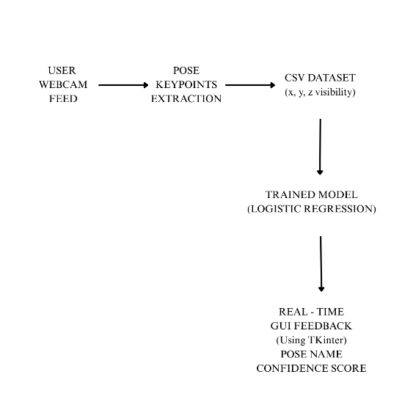

**Figure 1.** System architecture outlining the physiotherapy pose detection pipeline using MediaPipe and machine learning.

**5.3 Evaluation and Classification:**

This model was evaluated on a test dataset using two classifiers: logistics regression and ridge classifier. Logistics regression was chosen to achieve the highest accuracy and provide a real system.

|  |  |  |  |
| --- | --- | --- | --- |
| Model | Train­ing Ac­cu­racy | Testing Accu­racy | Aver­age F1-Score |
| Logistic Regres­sion | 91% | 82% | 0.81 |
| Ridge Classifier | 88% | 78% | 0.76 |

**Table 2.** Comparative model performance based on accuracy and F1-score.

**5.4 GUI Results:**

**Figure 2** shows the live GUI interface. The interface recognizes Poses, shows reliable predictive names, and uses voice feedback to lead users. Supports personalized registration and session initialization for users performing rehabilitation exercises.



**Figure 2.** Real-time GUI detection and feedback output during user execution.

**6.RESULTS**

The system showed strong performance in accurate classification of physical therapy from live webcam input. The logistics regression model achieved 91% training accuracy and 82% testing accuracy. This demonstrates the ability to properly generalize to invisible data. An average F1 score of 0.81 continues to confirm the robustness of the model across all seven pose classes.

In the live version, poses such as wrist tracks, grip movements, and arm rotation were classified with high reliability under stable lighting conditions. The system showed minor power fluctuations when multiple users were encountered in a frame or when parts of the body were closed. The tracking of the landmark was also affected by sudden hand movements and background impairments. This underscored the importance of a proper setup for optimal results. As a result, users were able to dynamically adjust their attitudes throughout the session and maintain the correct form. Overall, the results examine the system's ability to act as an effective device for home-based unattended physiotherapy.

**6.1 Performance Diagram: Pose Accuracy Comparison**

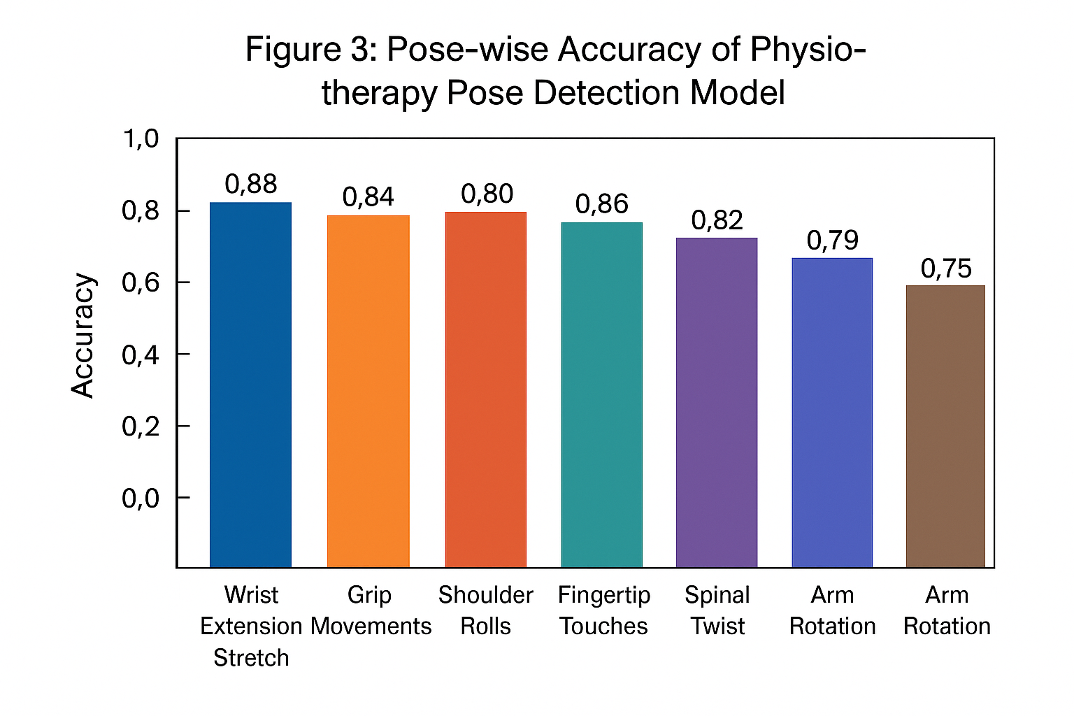

**Figure 3.** Accuracy of pose classification for each physiotherapy exercise, showing consistent performance above 75% for all poses tested.

**7.FUTURE WORK**

# The future development of the proposed physiotherapy recognition system will focus on improving model accuracy and increasing access through devices. Data magnification technologies such as rotation, scaling and lighting variations can improve generalization under a variety of real conditions. Additionally, the system is integrated into mobile applications, allowing users to conveniently perform exercises on their smartphones. Including language-based interactions and gesture-controlled navigation also improves prospects, especially in patients with limited mobility. In a clinical setting, the Remote Monitoring-Dashboard allows therapists to assess performance and adapt their treatment plans accordingly.

**8.CONCLUSION**

# This study shows a feedback system that uses media capix fermentation for real-time detection of physiotherapy, and a logistic regression classification for detection of Poznan. The system supports seven important exercises of upper body and spinal physiotherapy and delivers via an easy-to-use GUI. Despite the challenges such as occlusion and background interference, modular design allows for continuous improvement and future scalability. The system contributes to the digital transformation of healthcare by providing cost-effective, AI-controlled solutions for remote Fiji therapy monitoring.

**REFERENCE**

# V. Akuhota and S. F. Nedler,” Core Strengthening,” American Academy of Physical Medicine and Rehabilitation, 2004.

# R. Szeliski,” Computer Vision: Algorithms and Applications,” Springer, 2010.

# G. Bradski and A. Kaehler,” Learning OpenCV,” O’Reilly, 2008.

# Z. Cao, T. Simon, S.-E. Wei and Y. Sheikh,” Realtime Multi-Person 2D Pose Estimation using Part Affinity Fields,” The Robotics Institute, Carnegie Mellon Uni- versity, 2017.

# P. Ganesh,” Human Pose Estimation: Simplified,” Towards Data Science, 26 March 2019. [Online]. Available: https://towardsdatascience.com/human-pose- estimation- simplified6cfd88542ab3. [Accessed 3 April 2020].

# S.-E. Wei, V. Ramakhrisna, T. Kanade and Y. Sheikh,” Convolutional Pose Ma- chines,” The Robotics Institute Carnegie Mellon University, 2016.

# P. K. Borkar, M. M. Pulinthitha and A. Pansare,” Match Pose - A System for Comparing Poses,” International Journal of Engineering Research Technology (IJERT), vol. 8, no. 10, 2019.

# M. C. Thar, K. Z. N. Winn and N. Funabiki,” A Proposal of physiotherapy Pose Assessment Method Using Pose Detection for Self- Learning,” University of Infor- mation Technology Okayama University.

# S. K. Yadav, A. Singh, A. Gupta and J. L. Raheja,” Real-time physiotherapy recognition using deep learning,” Springer-Verlag London Ltd., 2019.

# H. Hanaizumi and H. Misono,” An OpenPose Based Method to Detect Texting while Walking,” 7th IIAE International Conference on Intelligent Systems and Im- age Processing 2019, 2019.

# K. Chen,” Sitting Posture Recognition Based on OpenPose,” IOP Publishing Ltd, 2019.

# S. Jin, X. Ma, Z. Han, Y. Wu, W. Yang, W. Liu, C. Qian and W. Ouyang,” Towards Multi-Person Pose Tracking: Bottom-up and Topdown Methods,” ICCV2017, 2017.